Bag of Words (BoW):
Bag of Words (BOW):
In NLP, text data must be converted to numerical data so that the machine learning algorithms can process it. Bag of Words(BOW) is simple and commonly used methods for this.
- Converts text (sentence, paragraph, or document) into a collection of words
- Counts how often each word appears in the text
- Ignores word order and grammar, focusing only on frequency

Step 1: Preprocessing the Text
- Converting the text to lowercase
- Removing non-word characters
- Removing extra spaces

Step 2: Counting the frequency
In this step, we count the frequency of each word in the preprocessed text. We will store these counts in a pandas DataFrame to view them easily in a tabular format.
- We initialize a dictionary to hold our word counts.
- Then, we tokenize each sentence into words.
- For each word, we check if it exists in our dictionary. If it does, we increment its count. If it doesn’t, we add it to the dictionary with a count of 1.

Step 3: Selecting the Most Frequent Words
- Now that we have counted the word frequencies, we will select the top N most frequent words (e.g top 10) to be used in the BoW model.
Step 4: Building the Bag of Words (BOW) Model
- Now we will build the Bag of Words (BoW) model.
- This model is represented as a binary matrix where each row corresponds to a sentence and each column represents one of the top N frequent words.
- We will use a heatmap to visualize this binary matrix where green shows the presence of a word (1) and red shows its absence (0).
Step 5: Visualize word Frequencies with Word Cloud
- Finally, we can create a Word Cloud to visually represent the word frequencies.
- In a word cloud, the size of each word is proportional to its frequency which makes it easy to identify the most common words at a glance.

Code:
# Bag Of Words

# Step 1: Preprocessing the text

import re
import nltk
import pandas as pd
from nltk.corpus import stopwords
import heapq
import matplotlib.pyplot as plt
import numpy as np
import seaborn as sns
from wordcloud import WordCloud

text = """Beans. I was trying to explain to somebody as we were flying in, that's corn.
That's beans. And they were very impressed at my agricultural knowledge.
Please give it up for Amaury once again for that outstanding introduction.
I have a bunch of good friends here today, including somebody who I served with,
who is one of the finest senators in the country, and we're lucky to have him,
your Senator, Dick Durbin is here. I also noticed, by the way,
former Governor Edgar here, who I haven't seen in a long time, and
somehow he has not aged and I have. And it's great to see you, Governor.
I want to thank President Killeen and everybody at the U of I System for
making it possible for me to be here today. And I am deeply honored at the Paul
Douglas Award that is being given to me. He is somebody who set the path for so
much outstanding public service here in Illinois. Now, I want to start by
addressing the elephant in the room. I know people are still wondering why
I didn't speak at the commencement."""

dataset = nltk.sent_tokenize(text)

for i in range(len(dataset)):
dataset[i] = dataset[i].lower()
dataset[i] = re.sub(r'\W',' ',dataset[i])
dataset[i] = re.sub(r'\s+',' ',dataset[i])

for i, sentence in enumerate(dataset):
print(f"Sentence {i+1}: {sentence}")

# Step 2: Counting Frequencies

word2count = {}

for data in dataset:
words = nltk.word_tokenize(data)
for word in words:
if word not in word2count:
word2count[word] = 1
else:
word2count[word] += 1

stop_words = set(stopwords.words('english'))

filter_word2count = {word : count for word, count in word2count.items() if word not in stop_words}

word_freq_df = pd.DataFrame(list(filter_word2count.items()),columns=['Word','Frequency'])

word_freq_df = word_freq_df.sort_values(by='Frequency', ascending=False)

print(word_freq_df)

# Step 3 : Selecting the most frequent words

freq_words = heapq.nlargest(10,word2count,word2count.get) # n = 10 for top 10, word2count->stored place,.get-> is used to get the values

print(f"Top 10 frequent words: {freq_words}")

top_words = sorted(word2count.items(), key = lambda x:x[1],reverse=True)[:10]
words, counts = zip(*top_words) # * is used to unpack the top_words

plt.figure(figsize=(10,6)) # width = 10 , height = 6
plt.bar(words,counts,color='skyblue')
plt.xticks(rotation = 45)
plt.title('Top 10 Most Frequent Words')
plt.xlabel('Words')
plt.ylabel('Frequency')
plt.show()

# Step 4 : Building Bag Of Words (BOW) Model

X = []

for data in dataset:
vector = []
for word in freq_words:
if word in nltk.word_tokenize(data):
vector.append(1)
else:
vector.append(0)
X.append(vector)

X = np.asarray(X)

plt.figure(figsize=(10, 6))
sns.heatmap(X, cmap='RdYlGn', cbar=False, annot=True, fmt="d", xticklabels=freq_words, yticklabels=[f"Sentence {i+1}" for i in range(len(dataset))])

plt.title('Bag of Words Matrix')
plt.xlabel('Frequent Words')
plt.ylabel('Sentences')
plt.show()

# Step 5: Visualiza word frequency using WordCloud

wordcloud = WordCloud(width=800,height=800,background_color='white').generate_from_frequencies(word2count)
plt.figure(figsize=(10,6))
plt.imshow(wordcloud,interpolation='bilinear')
plt.axis('off')
plt.title("Word Cloud of Frequency words")
plt.show()

Output:
PS C:\Users\mohammed.yousuf\Documents\NLP\day14> py bow.py

Sentence 1: beans
Sentence 2: i was trying to explain to somebody as we were flying in that s corn
Sentence 3: that s beans
Sentence 4: and they were very impressed at my agricultural knowledge
Sentence 5: please give it up for amaury once again for that outstanding introduction
Sentence 6: i have a bunch of good friends here today including somebody who i served with who is one of the finest senators in the country and we re lucky to have him your senator dick durbin is here
Sentence 7: i also noticed by the way former governor edgar here who i haven t seen in a long time and somehow he has not aged and i have
Sentence 8: and it s great to see you governor
Sentence 9: i want to thank president killeen and everybody at the u of i system for making it possible for me to be here today
Sentence 10: and i am deeply honored at the paul douglas award that is being given to me
Sentence 11: he is somebody who set the path for so much outstanding public service here in illinois
Sentence 12: now i want to start by addressing the elephant in the room
Sentence 13: i know people are still wondering why i didn t speak at the commencement
Word Frequency
3 somebody 3
0 beans 2
17 today 2
12 outstanding 2
41 want 2
.. ... ...
67 people 1
68 still 1
69 wondering 1
70 speak 1
71 commencement 1

[72 rows x 2 columns]
Top 10 frequent words: ['i', 'the', 'to', 'and', 'in', 'for', 'here', 'that', 'at', 'who']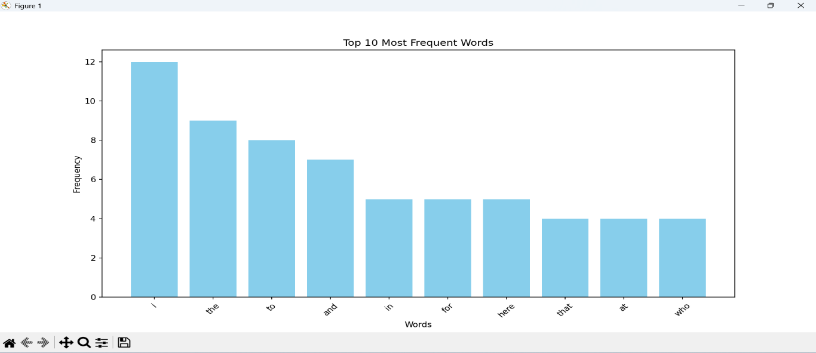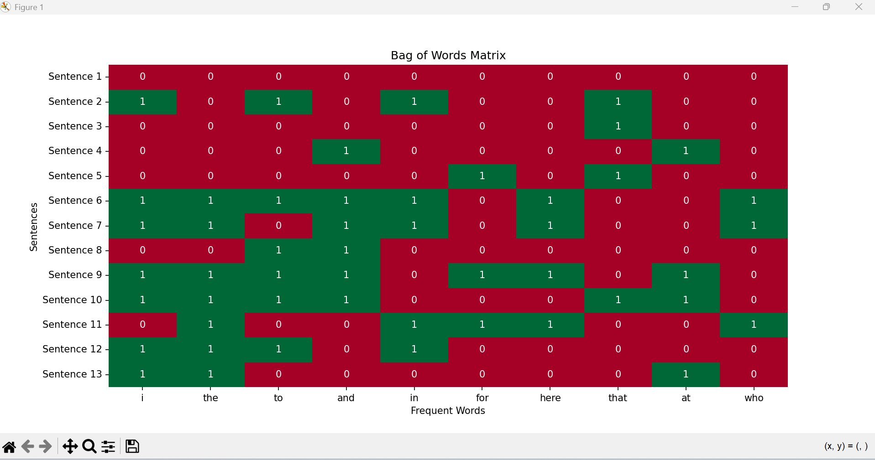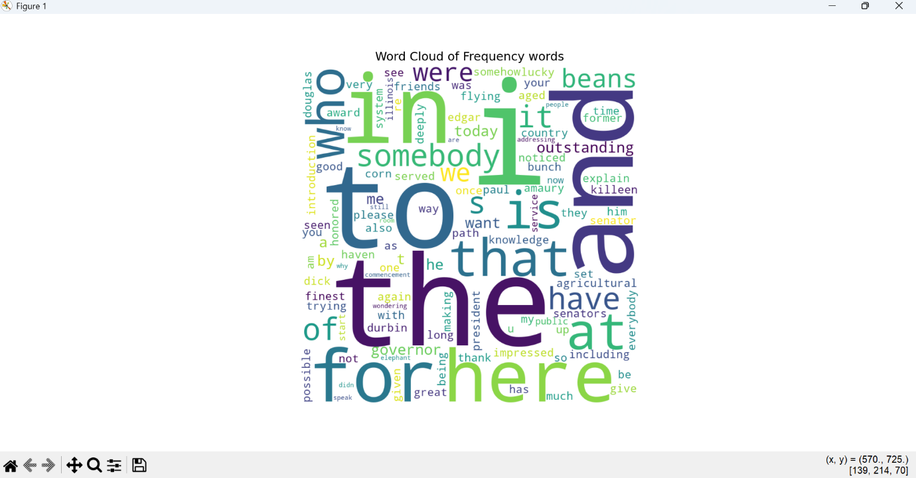

Term Frequency – Inverse Document Frequency (TF-IDF):
Term Frequency – Inverse Document Frequency (TF-IDF) is a statistical methods used for natural language processing and information retrieval to evaluate how important a word is to a document in relation to a larger collection of documents.
- Term Frequency (TF):
Measures How often a word appears in the document. A Higher frequency suggests greater importance.
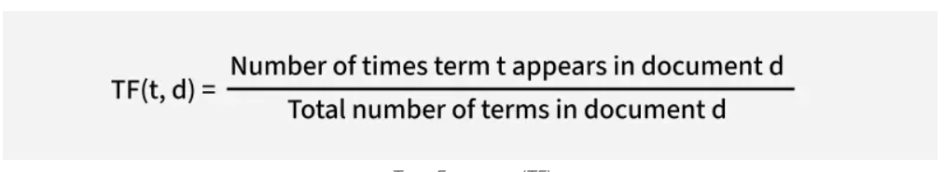
- Inverse Document Frequency (IDF):
Reduces weight of the common word across multiple documents while increasing the weight of the rare words. If a term appear rarely in fewer documents, it is more meaningful and specific.
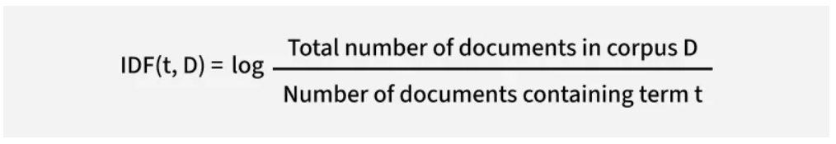
This balance allows TF-IDF to highlight terms that are both frequent within a specific document and distinctive across the text document, making it a useful tool for tasks like search ranking, text classification and keyword extraction.

Convert text into vectors with TF-IDF:
- Document 1: "The cat sat on the mat."
- Document 2: "The dog played in the park."
- Document 3: "Cats and dogs are great pets."
Focus on word “cat” and evaluate TF-IDF for this.
Step 1: Calculate Term Frequency
For Document 1 :
- The “cat” appears 1 time (t)
- Total Number of terms in document 1 is 6(d) (“The”,”cat”,”sat”,”on”,”the”,”mat”)
- Term Frequency (TF) is TF(cat,document1) = 1/6
For Document 2:
- The “cat” appears 0 time (t)
- Total Numbers of terms in document 2 is 6(d) (“The”,”dog”,”played”,”in”,”the”,”park”)
- Term Frequency (TF) is TF(cat,document2) = 0/6
For Document 3:
- The “cat” appears 1 time (t)
- Total Number of terms in document 3 is 6(d) (“Cats”,”and”,”dogs”,”are”,”great”,”pets”)
- Term Frequency (TF) is TF(cat,document3) = 1/6
In Document 1 and Document 3 the term “cat” has same TF score that shows that it has same relative frequency in both documents. But in document 3, The TF score is 0.
Step 2: Calculate Inverse Document Frequency
- Total Number of Documents in the corpus (D): 3
- Number of documents containing the term “cat”: 2 (Document 1 and 3)
IDF(cat,D) = log 3/2 ~ 0.176
Step 3: Calculate TF-IDF
TF – IDF(t,d,D) = TF(t,d) X IDF(t,D)
For Document 1, TF-IDF(cat,Document1,D) – 0.167 * 0.176 ~ 0.029
For Document 2, TF-IDF(cat,Document2,D) – 0 * 0.176 ~ 0
For Document 3, TF-IDF(cat,Document3,D) – 0.167 * 0.176 ~ 0.029

The TF-IDF score for "cat" is 0.029 in Document 1 and Document 3 and 0 in Document 2 that reflects both the frequency of the term in the document (TF) and its rarity across the corpus (IDF).
Code:
# Term Frequency - Inverse Document Frequency (TF-IDF)

from sklearn.feature_extraction.text import TfidfVectorizer

# Collect strings from documents and create a corpus
d0 = 'Geeks for geeks'
d1 = 'Geeks'
d2 = 'r2j'
string = [d0, d1, d2]

# Get TF-IDF Values

tfidf = TfidfVectorizer()
result = tfidf.fit_transform(string)

# Display IDF Values
print('\nIDF Values:')

for ele1,ele2 in zip(tfidf.get_feature_names_out(),tfidf.idf_):
print(ele1, ':', ele2)

print("Word Indexes:\n")
print(tfidf.vocabulary_)
print("\nTf-IDF values:")
print(result)
print("\n TF-IDF values in matrix form:")
print(result.toarray())

Output:

IDF Values:
for : 1.6931471805599454
geeks : 1.2876820724517808
r2j : 1.6931471805599454

Word Indexes:

{'geeks': 1, 'for': 0, 'r2j': 2}

Tf-IDF values:
<Compressed Sparse Row sparse matrix of dtype 'float64'
with 4 stored elements and shape (3, 3)>
Coords Values
(0, 1) 0.8355915419449176
(0, 0) 0.5493512310263033
(1, 1) 1.0
(2, 2) 1.0

TF-IDF values in matrix form:
[[0.54935123 0.83559154 0. ]
[0. 1. 0. ]
[0. 0. 1. ]]

N- Gram Language Modelling with NLTK:
Language modeling involves determining the probability of a sequence of words. It is fundamental to many Natural Language Processing (NLP) applications such as speech recognition, machine translation and spam filtering where predicting or ranking the likelihood of phrases and sentences is crucial.

N-grams:
N-gram is a language modelling technique that is defined as the contiguous sequence of n items from a given sample of text or speech. The N-grams are collected from a text or speech corpus. Items can be:
- Words like “This”, “article”, “is”, “on”, “NLP” → unigrams
- Word pairs likw “This article”, “article is”, “is on”, “on NLP” → bigrams
- Triplets (trigrams) or larger combinations

N-gram Language Model:
N-gram uses the previous words to predict the probability of the next word.
p(w | h) => w - next word, h – context / history
Eg. “The article is on…” and to predict the likelihood “NLP” as next word.
p( “NLP” | “The” , “article” , “is” , “on” )

Chain Rule of Probability:
Probability of sentence = probability of each word occurring after previous words
Eg. “I love NLP”
P(I , love, NLP) = P( I ) X P(love | I) X P(NLP | I, love)

But, It is very difficult because:
- Requires huge memory
- Needs massive training data
- Many word combinations may never appear and this problem is called Data sparsity.
Markov Assumption:
To reduce complexity, N-grams models assume the probability of words depends only on previous n-1 words.
Eg.
Instead of p( NLP | The article is on )
Trigram Model => p( NLP | is on)
Bigram Model => p( NLP | on )
Evaluation Language Models:
  - Entropy:
Measures the uncertainty or randomness in a probability distribution.
Where,
p(x) = probability of word/event x
log(p(x)) = measures information content
H(p) is always >=0

if probability is high, then surprise is low
if probability is low, then surprise is high

Eg. Tomorrow’s Sunrise => very certain => Entropy is low
Next word prediction in random sentence => Entropy is high

  - Cross Entropy:
Cross Entropy measures how well a predicted distribution matches actual distribution
Where,
p(x) = true probability distribution
q(x) = predicted probability distribution by the model
H(p,q) >= H(p)

  - Perplexity:
Exponential of cross entropy. Lower the values indicates better model.

Code:
# N-Gram Natural Language Modelling with NLTK

import nltk
from nltk import trigrams
from nltk.corpus import reuters
from collections import defaultdict

nltk.download('reuters')
nltk.download('punkt')

words = nltk.word_tokenize(' '.join(reuters.words()))
tri_grams = list(trigrams(words))

model =defaultdict(lambda: defaultdict(lambda:0))

for w1,w2,w3 in tri_grams:
model[(w1,w2)][w3] += 1

for w1_w2 in model:
total_count = float(sum(model[w1_w2].values()))
for w3 in model[w1_w2]:
model[w1_w2][w3] /= total_count

def predict_next_word(w1,w2):
next_word_probs = model[w1,w2]
if next_word_probs:
return max(next_word_probs,key=next_word_probs.get)
else:
return "No prediction available"

print("Next word:",predict_next_word('the','stock'))

Output:
Next word: of

